THE FAIRMONT-MORGANTOWN HOUSING AUTHORITY
REQUEST FOR PROPOSALS (RFP)
FOR WOOD FRAMING SERVICES OF RESIDENTIAL STRUCTURE
AUGUSTA PINES DEVELOPEMENT, FAIRMONT, WV

The Fairmont-Morgantown Housing Authority (FMHA) invites the submittal of proposals to this RFP from qualified companies interested in providing home framing services for residential structure and garage located at 38 Augusta Pines Drive, Fairmont, WV. The residential build site is outside the city limits of Fairmont, WV.

Responses are solicited for this service in accordance with the terms, conditions, and instructions set forth in the RFP guidelines.

The Request for Proposals document may be obtained from FMHA central office upon request or through FMHA web site at www.fmhousing.com. Request for Proposals documents will also be mailed upon request; however, FMHA is not responsible to ensure timely delivery of mailed Request for Proposals documents. Receipt of responses does not bind the FMHA to any contract for said services, nor does it guarantee that a contract for the Project will be awarded.

Direct all questions for this RFP by Monday, October 1, 2018 in written form to: Scott Willis via email to swillis@fmhousing.com

FMHA reserves the right to reject any item in the proposal, to reject any and all proposals, to waive any informality herein and to cancel the RFP.

I. PURPOSE OF RFP
The Fairmont-Morgantown Housing Authority invites the submittal of proposals, to this Request for Proposals (RFP), from a qualified company interested in providing framing services for a residential structure located at 38 Augusta Pines Drive, Fairmont, WV.

II. LOCATION
The project is located on Augusta Pines Drive in Fairmont, Marion County, WV. The project site is not within the city limits of Fairmont.
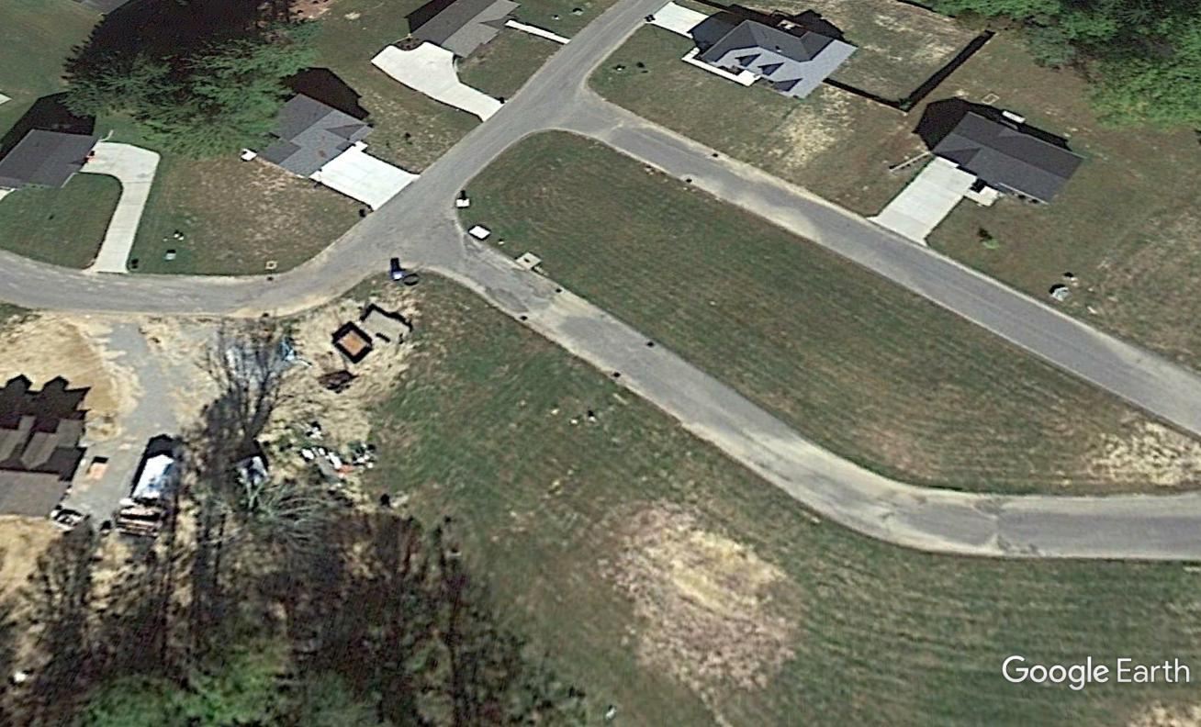
Residential
Build Site

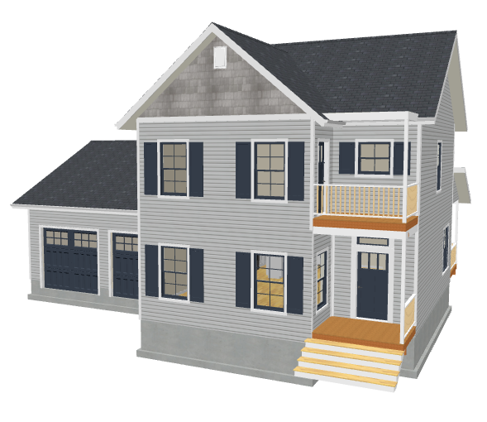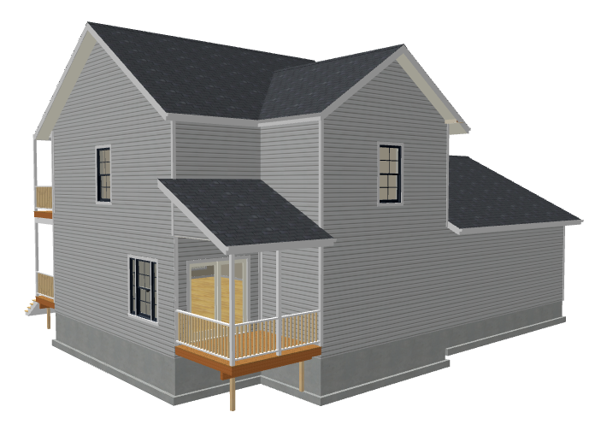
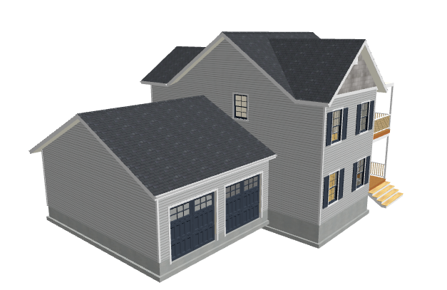

III. SCOPE OF WORK

- Frame two story residential home on crawlspace foundation provided by FMHA. 1840 Sq. Ft. of living space.
- Frame single story attached garage on foundation provided by FMHA. 720 Sq. Ft. of open garage space.
- Treated 2X10 pressure treated dimensional lumber sill plates will be installed by FMHA prior to the start of framing.
- First story floor framing will be constructed using a 3 ply center beam, floor joists and rim joists from 2X dimensional lumber. Foundation stiffening blocking shall be installed per Superior Walls foundation systems recommendations. Two rows of steel tension bridging shall be installed in floor framing system.
- Subfloor shall be glued and nailed to framing members per manufacturer recommendations.
- Frame all exterior walls utilizing 2X6 dimensional lumber with 7/16” OSB exterior sheeting. Garage walls to be framed using 2X4 dimensional lumber with 7/16” OSB.
- Install all exterior window and door headers utilizing 2X12 dimensional lumber, two ply hollow beam design (drawing to be provided). Install interior wall solid headers using 2X12 dimensional lumber at load bearing areas.
- Frame second story floor system using engineered floor truss system. Truss system shall be installed per manufacturer specifications.
- All second story interior and exterior walls to be framed as outlined above.
- Frame roof system, house and garage, using engineered roof truss system. Truss system shall be installed per manufacturer specifications. Hand frame tie in areas not supplied with truss system.
- Rear porch roof beam shall be constructed utilizing a box beam system using 2X4 and 2X10 dimensional lumber. Beam bearing points at exterior walls shall be pocketed into exterior wall system.
- Garage door beams will utilize LVL structural lumber.
- Build and install all rake and fascia boards on roof framing system for a 12” overhang.
- Eave boxes will be installed on all gable roof ends/walls. Boxes shall be constructed of 2X dimensional lumber. Boxes shall be level and return flush to the adjacent eave wall.
- Install 5/8” OSB sheeting on entire enclosed roof area. Roof sheeting shall include sheeting clips, between rows, installed on horizontal runs centered between each truss spacing.
- Roof sheeting shall be cut 2” below roof peak areas for installation of ridge vent system.
- Self-stick ice/dam water shield membrane shall be installed in a width of no less than 36” in width the entire length of all roof eaves. This material must also be utilized in all valley areas and on entire roof surfaces equal to or less than 3/12 pitch roof systems. The remainder of the roof surface shall be covered with synthetic felt material adequately nailed, with button cap fasteners, per manufacturer’s specifications.
- All exterior OSB sheeted walls and exposed framing materials (less roof system components) shall be covered with fabric house wrap. House wrap is to be adequately nailed to perform as intended. All seams in house wrap must be sealed (taped) making the wrap a continuous closed system.
- All framing components shall be installed level, plumb and square.
- The contractor shall contact FMHA immediately for foreseen or unforeseen issues with drawing dimensions or problems that impede the project or the scope of work.
- Work area shall be cleaned routinely and final clean of all construction debris upon completion of project. An area or construction dumpster will be provided on the build site for debris to be placed.
- FMHA will provide all materials to complete the framing of the home. The contractor shall provide FMHA with all pneumatic nailers to be used for proper supply of fasteners. All framing fasteners shall be 16P full head sinkers. All floor sheeting fasteners shall be ring shank 8P. All wall sheeting fasteners shall be 6P-8P ring shank nails. All roof felt and house wrap fasteners shall be plastic button cap type. The contractor can choose to provide all fasteners for the project and include costs with the proposal.
- Contractor is responsible for maintaining the work within the property boundaries including debris, tools and machinery. Property boundaries will be marked by FMHA.
- Contractor is responsible for understanding and following OSHA guidelines for safety of all workers. The contractor shall not hold FMHA liable for financial, medical or legal liability issues arising from non-compliant OSHA work standards.
- Floor plans and a material take off list will be provided to the contractor.
- Superior Walls blocking specifications will be provided to the contractor.
- Engineered floor/roof system layouts and bracing specifications will be provided to the contractor.
- All door and window rough openings will be provided to the contractor.
- All work shall be performed in compliance current local, State and Federals codes governing this scope of work.

This shall be a fixed price proposal including all elements of the scope of work. The contract agreement will provide for payment as follows:
- 50% upon completion of framed floors and walls
- 50% upon completion of entire project
Final invoice will be approved for payment upon final walkthrough and determination that all components of the scope of work have been completed.
FMHA will provide payment within 14 business days of receipt of approved invoice(s).

IV. No Obligation – FMHA reserves the right to: (1) evaluate the proposals submitted; (2)
waive any irregularities therein; (3) accept any proposal (4) reject any or all proposals

V. Licensing and Insurance – The selected company shall provide FMHA the following within five (5) business days of notice of acceptance of proposal:
- State of West Virginia Contractors License
- State of West Virginia Business License
- Proof of Workers Compensation for all employees working on project
- Proof of Liability Insurance
- Completed W-9

VI. Completion Schedule – The selected company shall complete all work (scope of work) within 30 days from the notice to proceed.

VII. Financial Responsibility – The selected company shall be responsible for all local, State and Federal Taxes, permits and any other fees associated with completion of project. The selected company, upon payment of agreed contractual price, shall not place any type of mechanics or material lien on the property located at 38 Augusta Pines Drive, Fairmont, WV 26554.

VIII. Submittal Instructions
Proposals can be delivered to the FMHA, 103 12th Street, Fairmont, WV 26554, mailed to Fairmont – Morgantown Housing Authority, PO Box 2738, Fairmont, WV 26554 or emailed to swillis@fmhousing.com before 2:00 pm on Friday October 5, 2018. All proposals must be labeled – “Augusta Pines Lot 15”. All emailed proposals must be labeled “Augusta Pines Lot 15” in the subject line. Late submittals may not be considered.

