THE FAIRMONT-MORGANTOWN HOUSING AUTHORITY
REQUEST FOR PROPOSALS (RFP)
FOR DEMOLITION SERVICES OF RESIDENTIAL STRUCTURE
VIRGINIA AVENUE, FAIRMONT, WV

The Fairmont-Morgantown Housing Authority (FMHA) invites the submittal of proposals to this RFP from qualified companies interested in providing demolition services for residential structure and garage located at 1033 Virginia Avenue in Fairmont, WV.

Responses are solicited for this service in accordance with the terms, conditions, and instructions set forth in the RFP guidelines.

The Request for Proposals document may be obtained from FMHA central office upon request or through FMHA web site at www.fmhousing.com. Request for Proposals documents will also be mailed upon request; however, FMHA is not responsible to ensure timely delivery of mailed Request for Proposals documents. Receipt of responses does not bind the FMHA to any contract for said services, nor does it guarantee that a contract for the Project will be awarded.

FMHA reserves the right to reject any item in the proposal, to reject any and all proposals, to waive any informality herein and to cancel the RFP.

I. PURPOSE OF RFP
The Fairmont-Morgantown Housing Authority invites the submittal of proposals, to this Request for Proposals (RFP), from a qualified company interested in providing demolition services for a residential structure located at 1033 Virginia Avenue, Fairmont, WV.

II. LOCATION
The project is located on Virginia Avenue in Fairmont, Marion County, WV. The project site is within the city limits of Fairmont.
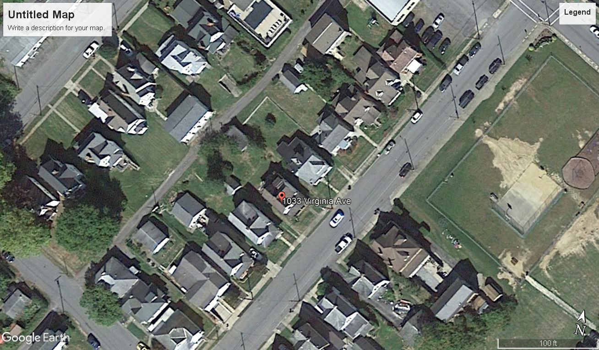

III. SCOPE OF WORK

- Demolition of 2 story wood framed residential home
- Demolition of single story masonry garage with wood framed roof system
- Removal of all concrete entrances such as stairs and sidewalks
- Removal of all demolition debris
- Demolition debris shall be legally disposed of in accordance with local, State and Federal law
- Disconnection of all active utilities including capping existing sewer tap outside of existing foundation
- The basement floor need not be removed
- Existing foundation area of home and garage to filled with clean earth and/or processed stone material
- Fill areas and ground areas damaged during demolition shall be covered with 2” minimum topsoil
- All areas of demolition without vegetation shall be seeded and mulched using a construction grade grass seed
- Contractor is responsible for controlling water runoff to adjoining properties and public areas during work
- Contractor is responsible for maintaining the work within the property boundaries including debris and machinery
This shall be a fixed price proposal including all elements of the scope of work. The contract agreement will provide for payment of work upon completion. Each company submitting a proposal shall include:
- One proposal utilizing the stone foundation as part of the fill for the excavated basement area
- One proposal for the removal of the stone foundation from the work site

IV. No Obligation – FMHA reserves the right to: (1) evaluate the proposals submitted; (2)
waive any irregularities therein; (3) accept any proposal (4) reject any or all proposals

V. Licensing and Insurance – The selected company shall provide FMHA the following within five (5) business days of notice of acceptance of proposal:
- State of West Virginia Contractors License
- State of West Virginia Business License
- City of Fairmont, West Virginia Business License
- Proof of Workers Compensation for all employees working on project
- Proof of Liability Insurance
- Completed W-9

VI. Completion Schedule – The selected company shall complete all work (scope of work) within 90 days from the notice to proceed.

VII. Financial Responsibility – The selected company shall be responsible for all local, State and Federal Taxes, permits and any other fees associated with completion of project. The selected company, upon payment of agreed contractual price, shall not place any type of mechanics or material lien on the property located at 1033 Virginia Avenue, Fairmont, WV 26554.

VIII. Submittal Instructions
Proposals can be delivered to the FMHA, 103 12th Street, Fairmont, WV 26554, mailed to Fairmont – Morgantown Housing Authority, PO Box 2738, Fairmont, WV 26554 or emailed to bgillespie@fmhousing.com before 2:00 pm on Friday, September 28, 2018. All proposals must be labeled – “Virginia Avenue Demolition Project”. All emailed proposals must be labeled “Virginia Avenue Demolition Project” in the subject line. Late submittals may not be considered.

