WVU Offers New Employee Down Payment Program~

West Virginia University has teamed with the Fairmont-Morgantown Housing Authority (FMHA) to offer an employee down payment assistance program to its faculty and staff wishing to purchase a home in targeted Morgantown neighborhoods.

These limited down payment funds are available on a first come first ready basis. Up to $10,000 at zero percent interest over ten years is available in the form of a forgivable loan for any eligible employee.

Funds can be used to purchase a single family, town house or duplex home in the near campus city neighborhoods of Wiles Hill, Greenmont, Woodburn and First Ward as part of the FMHA Morgantown Homecoming Program. FMHA can assist in the purchase or construction of a new home, attractive mortgage financing, and other homebuyer services. Once purchased the home cannot be rented and must be the owner’s primary residence. A deed restriction will be imposed to keep the home owner occupied.

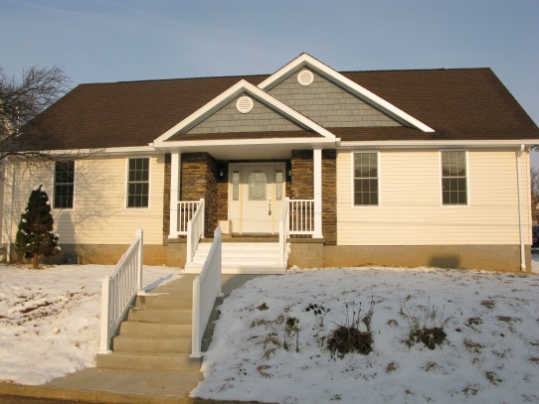
Morgantown Homecoming Property in 1st Ward

“We are happy to work with FMHA in their efforts to increase homeownership in Morgantown. “ We feel it only benefits WVU and our employees to have a healthy community in which to work and live”’ said Narvel Weese, WVU Vice President of Administration and Finance.

To be eligible an employee must be a full time equivalent of good standing. Full time employees of the WVU Research Corporation are also eligible. There are no income restrictions; however loan and house limitations may apply depending on lender requirements. Participation in an eight hour homebuyer education class is also required.

Please contact Christal Crouso at ccrouso@fmhousing.com or 304-363-0860 ext. 105 for full program details. Some restrictions apply.

